

School of Computing and Mathematics

PRCO303SL

Final Stage Computing Project

Smart Health Monitoring and Alerting System

Interim Report II

BSc (Hons) in Software Engineering

K. C. A. A. Iroshan

2019/2020

Table of Contents
1. Introduction 4
2. Tasks undertaken and outcomes 5
3. Products produced and product quality 6
3.1. Products 6
3.2. Quality and issues 6
4. Use Case Diagram 7
5. EER Diagram 8
5. Draft of the contents of the final project report 9
7. A draft of a chapter from the final project report 11
7. Schedule 12
6. Student learning undertaken and required 13

Table of Figures
Figure 1: Use Case Diagram 7
Figure 2: Extended Entity Relationship Diagram 8

- Introduction

When the patients are admitted to a hospital, they are treated and their health conditions are monitored. The most important vitals that need to be monitored are the blood pressure and the body temperature as the stability of a persons health depends on these two. Currently, on patient basis, these vitals are not recorded and profiled, and in order to monitor a patient, the medical staff have to check on the patient time to time. Sometimes, some patients will be needed for prolonged monitoring even after they’re released to their homes.

But other than with a dedicated medical personal, an effective remote monitoring system is yet to be implemented. It’s also necessary to store a brief medical history of patients to be used in case of an emergency situation for better preparation to handle the patient on the hospital’s side.

It’s more efficient to have a centralized computer based patient monitoring system where the medical staff of a hospital can monitor vitals of the admitted patients (who needs to be constantly monitored) and the released patients who also may need to be monitored, using remote monitoring, all in the same centralized system. If the medical staff gets alerted of a medical emergency of a patient with the access to that patient’s medical history, it’d help them immensely to get ready for the patient (if the patient is in remote monitoring, sending an ambulance to collect the patient), by arranging the hospital before the patient arrives at the hospital. This system would also be beneficial even when monitoring the already admitted patients, for quick attendance to the need.

- Tasks undertaken and outcomes

The IOT device that is used to obtain the vitals of the patients has been developed.

The IOT device once turned on takes inputs from the sensors and send the data to the cloud.

Development of the back end of the system is underway.

The API is being developed.

The database system has been developed.

- Products produced and product quality

  - Products

The system is consisted of an IOT device, a software application that displays the out puts of the IOT devices connected in a dashboard that also manages the details of the patients, and a database system that’s used to store all the data associated with the system.

The development of the software is ongoing whereas the IOT device is completed as a product and is undergoing testing.

The back end of the system is under development and the database system has been developed.

  - Quality

The parts of the device are placed under a quality housing to avoid the damage that could occur to the sensitive devices and the connections.

Each and every part of the device has undergone rigorous to make sure that they function properly.

Exception handling has been utilized in the parts of the software that have been developed to make sure that any error that exist is captured and taken care of and the object oriented concepts have been utilized for the program to work effectively.

- Use Case Diagram

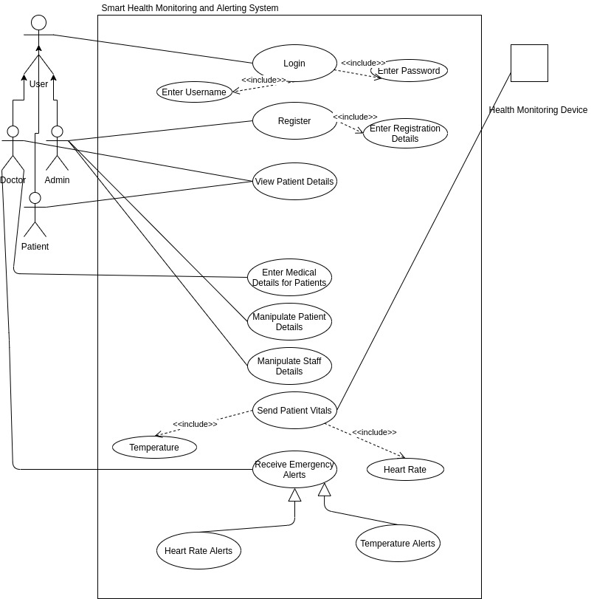Figure 1: Use Case Diagram

- EER Diagram

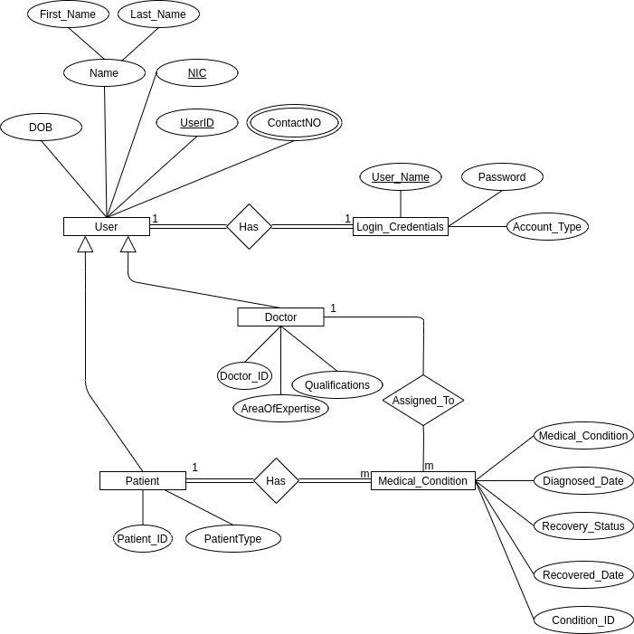Figure 2: Extended Entity Relationship Diagram

- Draft of the contents of the final project report

Acknowledgments
Abstract
- Introduction
  - Background
  - Business Case
  - Objectives
  - Scope
- Legal Social and Ethical Issues
  - Licenses
  - Data Protection
  - Privacy
  - Confidentiality
- System Analysis and Design
  - Requirement Development
    - Functional Requirements
    - Non functional requirements
  - Design
    - Architecture diagram
    - Extended Entity Relation Diagram
    - Use case diagram
    - Class diagram
    - Database Design
- Project Management
- Methods of approach
- Development technologies
  - IOT Device
  - Web application
- Learning requirements
- Testing
  - Unit testing
  - Functionality testing
  - Usability testing
- End-Project report
- Project Postmortem
  - Challenges faced
  - Future enhancements and implementations
    - Enhancements
    - Implementations
- Conclusion
- Bibliography
- Appendices
  - Technical documentation
  - User Manual
  - PID
  - Interim report 1
  - Interim report 2
  - User interface designs
  - User stories
  - Third party resources used
  - Additional studies undertaken
  - User test results

- A draft of a chapter from the final project report

- Introduction

When the patients are admitted to a hospital, they are treated and their health conditions are monitored. The most important vitals that need to be monitored are the blood pressure and the body temperature as the stability of a persons health depends on these two. Currently, on patient basis, these vitals are not recorded and profiled, and in order to monitor a patient, the medical staff have to check on the patient time to time. Sometimes, some patients will be needed for prolonged monitoring even after they’re released to their homes.

But other than with a dedicated medical personal, an effective remote monitoring system is yet to be implemented. It’s also necessary to store a brief medical history of patients to be used in case of an emergency situation for better preparation to handle the patient on the hospital’s side.

It’s more efficient to have a centralized computer based patient monitoring system where the medical staff of a hospital can monitor vitals of the admitted patients (who needs to be constantly monitored) and the released patients who also may need to be monitored, using remote monitoring, all in the same centralized system. If the medical staff gets alerted of a medical emergency of a patient with the access to that patient’s medical history, it’d help them immensely to get ready for the patient (if the patient is in remote monitoring, sending an ambulance to collect the patient), by arranging the hospital before the patient arrives at the hospital. This system would also be beneficial even when monitoring the already admitted patients, for quick attendance to the need.

- Schedule

Project Schedule 1st January 2020 to 6th April 2020
Week | 1 | 2 | 3 | 4 | 5 | 6 | 7 | 8 | 9 | 10 | 11 | 12 | 13 | 14 | 15
Interim Report 1
Software Design Completion
Supervisor Meeting
Representation of IOT data on the software
Testing the application dashboard
Research abstract
Interim Report 2
Development of the software
Testing the system
Poster Design
Final Project Report

- Student learning undertaken and required

Learning of the arduino libraries was needed.

Learning of the arduino electronics was needed.

Learning of API development was done on linked in learning and using you tube tutorials

Learning of javascript frameworks was done

